---------------------------------------------------------------------

-- LAB 08

--

-- Exercise 2

---------------------------------------------------------------------

USE TSQL;

GO

---------------------------------------------------------------------

-- Task 1

--

-- Write a SELECT statement against the Sales.Customers table and retrieve the custid and contactname columns. Add a calculated column named segmentgroup using a logical function IIF with the value “Target group” for customers that are from Mexico and have in the contact title the value “Owner”. Use the value “Other” for the rest of the customers.

--

-- Execute the written statement and compare the results that you got with the desired results shown in the file 62 - Lab Exercise 2 - Task 1 Result.txt.

---------------------------------------------------------------------

---------------------------------------------------------------------

-- Detyre 1

--

-- Selekto kolonat custid dhe contactname nga tabela Sales.Customers.Shto nje kolone te perllogaritur te quajtur segmentgroup duke perdorur nje funksion logjik IIF me vleren “Target group” per klientet qe jane nga Mexico dhe qe kane ne kolonen contact title vleren “Owner”. Perdor vleren “Other” per pjesen tjeter te klienteve.

--

-- Ekzekuto veprimet e mesiperme dhe krahaso rezultatin qe ju moret me rezultatin e deshiruar te treguar ne dokumentin 62 - Lab Exercise 2 - Task 1 Result.txt.

---------------------------------------------------------------------

Select sc.custid,sc.contactname,sc.country,sc.contacttitle ,

segmentgroup =(IIF((sc.country = 'Mexico' AND sc.contacttitle = 'Owner'),'Target group','Other'))

From Sales.Customers as sc

Order By sc.country,sc.contacttitle DESC

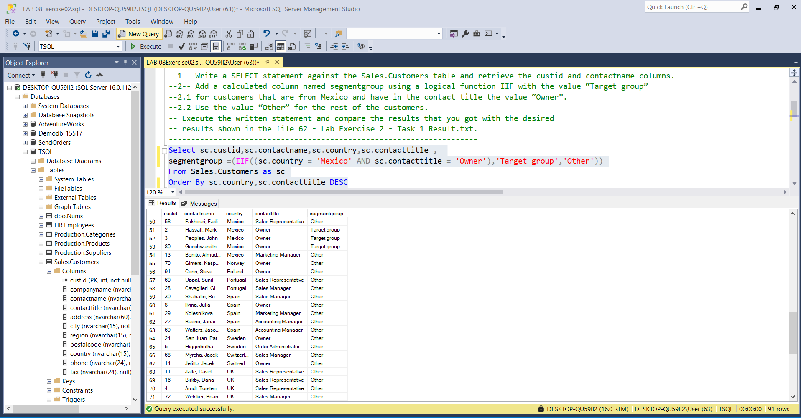

---------------------------------------------------------------------

-- Task 2

--

-- Modify the T-SQL statement from task 1 to change the calculated column to show the value “Target group” for all customers without a missing value in the region attribute or with the value “Owner” in the contact title attribute.

--

-- Execute the written statement and compare the results that you got with the recommended result shown in the file 63 - Lab Exercise 2 - Task 2 Result.txt.

---------------------------------------------------------------------

---------------------------------------------------------------------

-- Detyre 2

--

--1-- Modifiko veprimet T-SQL nga detyra 1 per te ndryshuar kolonen e perllogaritur per te treguar vleren “Target group” per te gjithe klientet pa patur ndonje vlere te munguar ne atributin region ose vleren “Owner” ne atributin e contact title.

--

--2-- Ekzekuto veprimet e mesiperme dhe krahaso rezultatin qe ju moret me rezultatin e deshiruar te treguar ne dokumentin 63 - Lab Exercise 2 - Task 2 Result.txt.

---------------------------------------------------------------------

--1--

Select sc.custid,sc.contactname,sc.country,sc.contacttitle ,

segmentgroup =(IIF((sc.country = 'Mexico' AND sc.contacttitle = 'Owner'),'Target group','Other'))

From Sales.Customers as sc

Where sc.country = 'Mexico' and sc.contacttitle ='Owner'

Order By sc.custid DESC

--2--

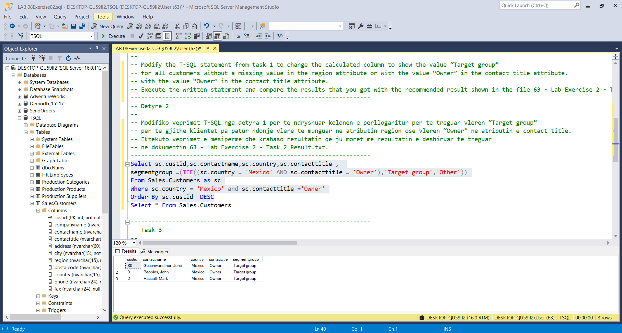

Rezultati i mësipërm:

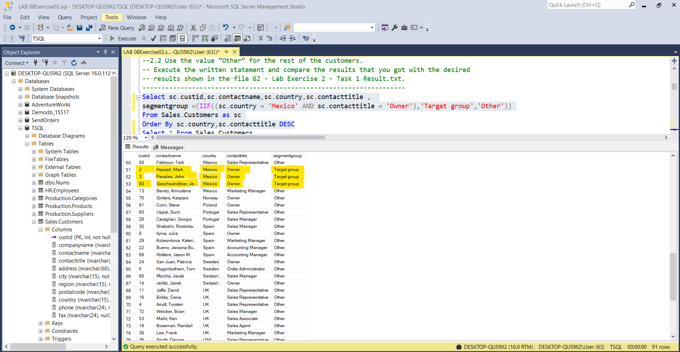

---------------------------------------------------------------------

-- Task 3

--

-- Write a SELECT statement against the Sales.Customers table and retrieve the custid and contactname columns. Add a calculated column named segmentgroup using the logic function CHOOSE with four possible descriptions (“Group One”, “Group Two”, “Group Three”, “Group Four”). Use the modulo operator on the column custid. (Use the expression custid % 4 + 1 to determine the target group.)

--

-- Execute the written statement and compare the results that you got with the recommended result shown in the file 64 - Lab Exercise 2 - Task 3 Result.txt.

---------------------------------------------------------------------

--------------------------------------------------------------------

-- Detyre 3

--

--1-- Nxjerr kolonat custid dhe contactname nga tabela Sales.Customers.Shto nje kolone te perllogaritur te quajtur segmentgroup duke perdorur funksionin logjik CHOOSE me kater mundesi pershkrimi(“Group One”, “Group Two”, “Group Three”, “Group Four”). Perdor operatorin modulo ne kolonen custid. (Perdor shprehjen custid % 4 + 1 per te percaktuar target group.)

--

-- Ekzekuto veprimet e mesiperme dhe krahaso rezultatin qe ju moret me rezultatin e deshiruar te treguar ne dokumentin 64 - Lab Exercise 2 - Task 3 Result.txt.

Select sc.custid , sc.contactname ,group_i = ((sc.custid%4)+1) ,segmentgroup = (IIF((((sc.custid%4)+1)>0),

CHOOSE(((sc.custid%4)+1),'Group One','Group Two','Group Three','Group Four'),'NULL'))

From Sales.Customers as sc

Order By sc.custid

